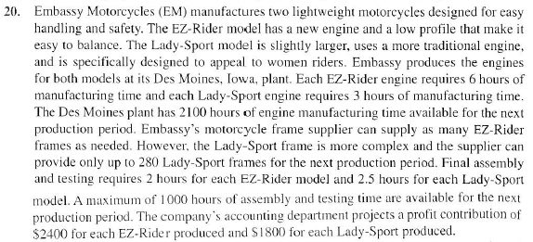

LP model:
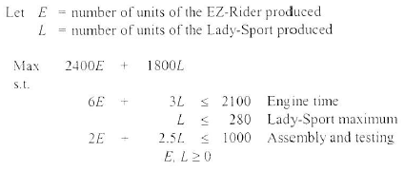

Using the LINDO output on the next page, answer each of the following:

- Give the range of optimality for each coefficient.

- Give the range of feasibility for each constraint.

- Will the optimal solution change if:
  - The profit contribution for each EZ-Rider is changed to 3400?
  - The profit contribution for each EZ-Rider is changed to 1400?
  - The profit contribution for each Lady-Sport is changed to 4000?
  - The profit contribution for each Lady-Sport is changed to 1500?

- Will the optimal solution change if:
  - The profit contribution for each EZ-Rider is changed to 3000 and the profit contribution for each Lady-Sport is changed to 2200 simultaneously?
  - The profit contribution for each EZ-Rider is changed to 3300 and the profit contribution for each Lady-Sport is changed to 1600 simultaneously?
- What will be the new maximum profit if:
  - 100 hours of available assembly time is added?
  - The maximum number of Lady-Sport motorcycles is increased to 5000?
  - 100 hours of available engine time is added?

- What will be the new maximum profit if:
  - 180 hours of engine time and 200 hours of assembly time are reduced simultaneously?
  - 120 hours of engine time and 150 hours of assembly time are reduced simultaneously?

